Player Position Card – 4-4-2

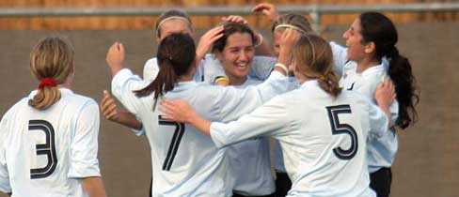
- 10

11 4 8 7

3 6 5 2

1

4-4-2

Roles & Responsibilities of Number 8 (Right-Sided Centre Midfielder)

No. 8 – Centre Midfielder

- Play Behind Opposition Full Backs When It’s On

- When Passing Into Forwards Feet, Try to Provide Support Behind The Ball

- Look for Opportunities When Ball Goes Into Strikers Feet to Make Attacking Run Beyond Front Line

- Play High Pressure Against Central Midfield Opponent’s (Particularly In First And Last 10 Minutes Of Each Half)

- Attack All Free Balls With Pace, Power & Purpose

